HTML5 – Day-1 Hands On – Chintha Ramakrishna

Problem 1
- Problem Statement - Create a basic HTML webpage using proper structure (DOCTYPE, head, body). Add a heading and paragraph introducing yourself, an unordered list of hobbies, an ordered list of daily routine steps, and a simple table showing Student Name, Subject, and Marks.

Code :-
<!doctype html>
<html>
<head>
<title>My First HTML page</title>
</head>
<body>
<h1>Welcome To My Page</h1>
<p> Hello! My name is Ramakrishna.</p>
<h2>My hobbies</h2>
<ul>
<li>Reading</li>
<li>Coding</li>
<li>Playing cricket</li>
</ul>
<h2>My daily routine</h2>
<ol>
<li>wakeup</li>
<li>exercise</li>
<li>study</li>
</ol>
<h2>Student details</h2>
<table border="2">
<tr>
<th>Student name</th>
<th>Subject</th>
<th>Marks</th>
</tr>
<tr>
<td>Ramakrishna</td>
<td>computer</td>
<td>90%</td>
</tr>
<tr>
<td>Hemanth</td>
<td>science</td>
<td>85%</td>
</tr>
<tr>
<td>akhil</td>
<td>social</td>
<td>92%</td>
</tr>

</table>
</body>
</html>

Output :- 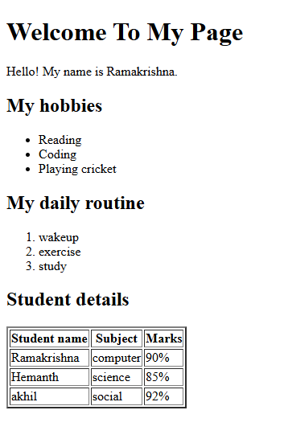

Explanation :-
- This HTML page starts with the basic structure including doctype, html, head, and body tags.
- Inside the body, a main heading and a paragraph are used to introduce yourself.
- An unordered list is created to show your hobbies like reading, coding, and playing cricket.
- An ordered list is used to display your daily routine steps in sequence.
- A table is created to show student details such as student name, subject, and marks in rows and columns.

Problem 2
- Problem Statement - Create a basic Restaurant Menu HTML webpage using proper HTML structure (DOCTYPE, head, body). The page should include a restaurant name as a heading, a paragraph about the restaurant, an unordered list showing menu categories, and a table displaying item name, category, and price. Use at least five HTML elements and include attributes like border, title, and align.

Code :-
<!DOCTYPE html>
<html>
<head>
<title>Spicy Delight Restaurant</title>
<style>
table {
border-collapse: collapse;
margin-left: 0;
}

th, td {
padding: 8px;
}
</style>
</head>
<body>

<h1>Spicy Delight Restaurant</h1>

<p>
Welcome to Spicy Delight! We serve fresh and delicious Indian food
with authentic taste and quality ingredients.
</p>

<h2>Menu Categories</h2>
<ul>
<li>Main Course</li>
<li>Breakfast</li>
<li>Beverages</li>
</ul>

<h2>Price List</h2>
<table border="1">
<tr>
<th>Item Name</th>
<th>Category</th>
<th>Price ($)</th>
</tr>
<tr>
<td>Paneer Butter Masala</td>
<td>Main Course</td>
<td>$220</td>
</tr>
<tr>
<td>Veg Biryani</td>
<td>Main Course</td>
<td>$180</td>
</tr>
<tr>
<td>Masala Dosa</td>
<td>Breakfast</td>
<td>$90</td>
</tr>
<tr>
<td>Cold Coffee</td>
<td>Beverages</td>
<td>$120</td>
</tr>
</table>

</body>
</html>

Output :-
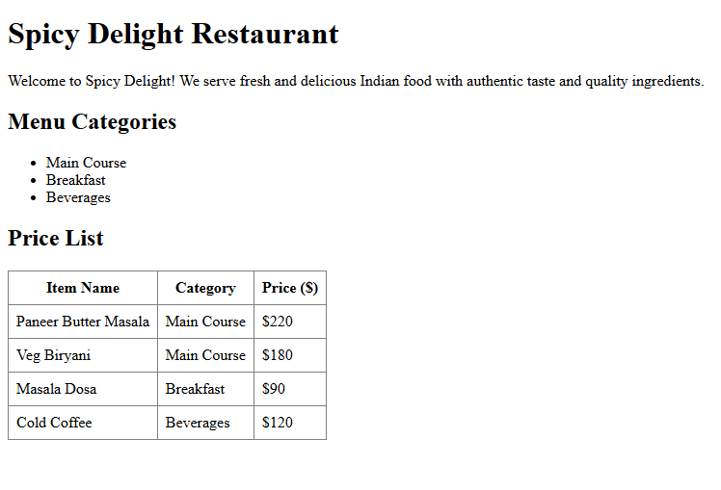
Explanation :-
- This HTML page uses the proper boilerplate structure including DOCTYPE, html, head, and body tags.
- The restaurant name is displayed using a heading tag, which makes it bold and important.
- A paragraph tag is used to describe the restaurant and give basic information about it.
- An unordered list is used to show different menu categories like Main Course, Breakfast, and Beverages.
- A table is created using <table>, <tr>, <th>, and <td> tags to display item name, category, and price in rows and columns.
- HTML attributes like border, title, and align are used to improve the appearance and structure of the webpage.

Problem 3
- Problem Statement - Create a basic HTML webpage titled Weekly Grocery Checklist that includes a main heading, an ordered list for high-priority items like rice and milk, and an unordered list for optional items like snacks and ice cream, using proper HTML structure and at least one attribute.
Code :-
<!DOCTYPE html>
<html>
<head>
<title>Weekly Grocery Checklist</title>
</head>
<body>
<!-- Main Heading -->
<h1 title="My Weekly Grocery Planning List">
Weekly Grocery Checklist
</h1>
<!-- High Priority Items -->
<h2>High Priority Items</h2>
<ol title="Essential Grocery Items">
<li>Rice</li>
<li>Milk</li>
<li>Vegetables</li>
<li>Cooking Oil</li>
</ol>
<!-- Optional Items -->
<h2>Optional Items</h2>
<ul title="Non-Essential Grocery Items">
<li>Snacks</li>
<li>Ice cream</li>
<li>Soft drinks</li>
</ul>
</body>
</html>

Output :-
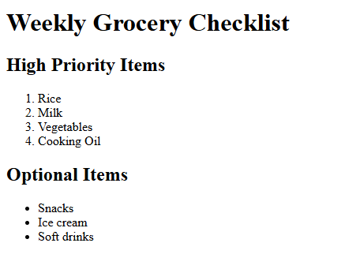
Explanation :-
- This HTML page uses the proper boilerplate structure including <!DOCTYPE html>, <html>, <head>, and <body> tags.
- The title “Weekly Grocery Checklist” is added inside the <head> section and also displayed as a main heading in the body.
- An ordered list <ol> is used to show high-priority grocery items like rice, milk, vegetables, and cooking oil in numbered form.
- An unordered list <ul> is used to display optional items like snacks, ice cream, and soft drinks in bullet points.
- The <li> tag is used for each item, and at least one attribute like title is included to provide additional information about the page.

Problem 4
- Problem Statement - Create an Employee Onboarding HTML page using semantic tags like <header>, <section>, <article>, and <footer>, including a table for employee details, an ordered list for company policies, and an unordered list for facilities, with proper structure and meaningful attributes.

Code :-
<!DOCTYPE html>
<html lang="en">
<head>
<title>Employee Onboarding Page</title>
<meta charset="UTF-8">
</head>
<body>
<!-- Header Section -->
<header title="Company Header">
<h1>ABC Technologies Pvt Ltd</h1>
<p>Welcome to the Employee Onboarding Portal</p>
</header>
<!-- Employee Details Section -->
<section>
<h2>Employee Information</h2>
<table border="1" title="Employee Details Table">
<tr>
<th>Employee ID</th>
<th>Name</th>
<th>Department</th>
<th>Joining Date</th>
</tr>
<tr>
<td>EMP101</td>
<td>Rama Krishna</td>
<td>Software Development</td>
<td>16-02-2026</td>
</tr>
</table>
</section>
<!-- Company Policies Article -->
<article>
<h2>Company Policies</h2>
<ol>
<li>Working hours: 9 AM to 6 PM</li>
<li>Leave policy: 12 paid leaves per year</li>
<li>Code of conduct must be followed strictly</li>
</ol>
</article>
<!-- Facilities Section -->
<section>
<h2>Facilities Provided</h2>
<ul>
<li>Laptop</li>
<li>Internet access</li>
<li>Training materials</li>
</ul>
</section>
<!-- Footer Section -->
<footer>
<p>Contact HR: hr@abctech.com</p>
<p>Phone: +91 9876543210</p>
</footer>
</body>
</html>

Output :-

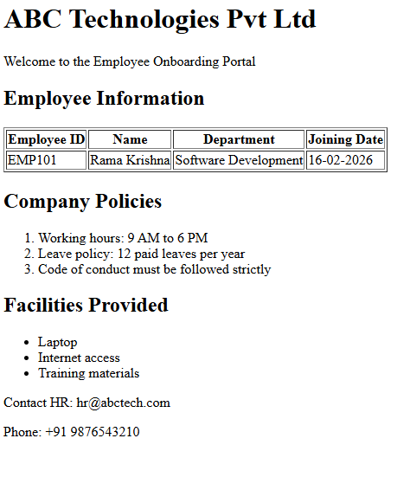

Explanation :-
- This HTML page uses semantic tags like <header>, <section>, <article>, and <footer> to organize the content clearly.
- The <header> section displays the company name and a welcome message for new employees.
- The <section> contains a table showing employee details such as Employee ID, Name, Department, and Joining Date.
- The <article> includes an ordered list that explains important company policies like working hours and leave policy.
- An unordered list is used to display facilities provided to employees such as a laptop and training materials.
- The <footer> provides contact information, and meaningful attributes like lang and title are added for better structure and accessibility.

Problem 5
- Problem Statement - Create a Computer Science Department HTML webpage using semantic tags that includes a header with college and department name, sections for faculty details, subjects offered, and weekly timetable (using tables and lists), and a footer with contact information.

Code :-
<!DOCTYPE html>
<html lang="en">
<head>
<meta charset="UTF-8">
<title>Computer Science Department - Jntu College</title>
</head>

<body>

<!-- Header Section -->
<header title="Department Header">
<h1>Jntu College of Engineering</h1>
<h2>Department of Computer Science</h2>
</header>

<!-- Section 1: Faculty Details -->
<section>
<h2>Faculty Details</h2>

<table border="1" title="Faculty Information Table">
<tr>
<th>Faculty Name</th>
<th>Designation</th>
<th>Subject Handled</th>
</tr>
<tr>
<td>Dr. Suresh Kumar</td>
<td>Professor</td>
<td>Data Structures</td>
</tr>
<tr>
<td>Ms. Anjali Rao</td>
<td>Assistant Professor</td>
<td>Database Management Systems</td>
</tr>
<tr>
<td>Mr. Ravi Teja</td>
<td>Lecturer</td>
<td>Web Technologies</td>
</tr>
</table>
</section>

<!-- Section 2: Subjects Offered -->
<section>
<h2>Subjects Offered</h2>

<ul title="List of Subjects">
<li>Data Structures</li>
<li>Database Management Systems</li>
<li>Operating Systems</li>
<li>Computer Networks</li>
<li>Web Technologies</li>
</ul>
</section>

<!-- Section 3: Weekly Timetable -->
<section>
<h2>Weekly Timetable</h2>

<table border="1" title="Weekly Timetable">
<tr>
<th>Day</th>
<th>Subject</th>
<th>Time Slot</th>
</tr>
<tr>
<td>Monday</td>
<td>Data Structures</td>
<td>9:00 AM - 10:00 AM</td>
</tr>
<tr>
<td>Tuesday</td>
<td>DBMS</td>
<td>10:00 AM - 11:00 AM</td>
</tr>
<tr>
<td>Wednesday</td>
<td>Operating Systems</td>
<td>11:00 AM - 12:00 PM</td>
</tr>
<tr>
<td>Thursday</td>
<td>Web Technologies</td>
<td>1:00 PM - 2:00 PM</td>
</tr>
<tr>
<td>Friday</td>
<td>Computer Networks</td>
<td>2:00 PM - 3:00 PM</td>
</tr>
</table>
</section>

<!-- Footer Section -->
<footer>
<p><strong>Address:</strong> Jntu College, Hyderabad, Telangana, India</p>
<p><strong>Contact:</strong> info@Jntucollege.edu | +91 9876543210</p>
</footer>

</body>
</html>

Output :-

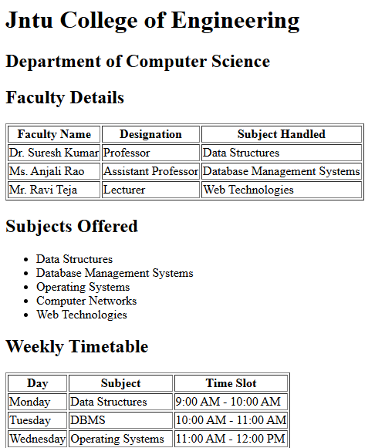
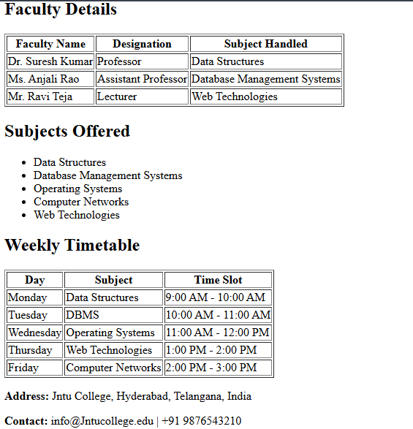
Explanation :-
- This HTML page uses proper structure with <!DOCTYPE html>, <html lang="en">, <head>, and <body> tags.
- The <header> section displays the college name and the Department of Computer Science as headings.
- The first <section> contains a table showing faculty details like faculty name, designation, and subject handled.
- The second <section> uses an unordered list to display the subjects offered by the department.
- The third <section> includes a table that shows the weekly timetable with day, subject, and time slot.
- The <footer> section provides the college address and contact information at the bottom of the page.

